**Performing Memory Analysis (Ubuntu)**

References : https://media.blackhat.com/bh-us-11/Case/BH_US_11_Case_Linux_Slides.pdf

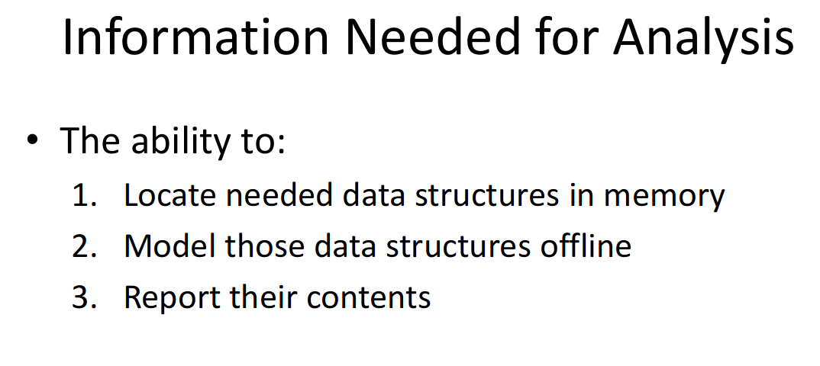

**To locate static data structures :**

System.map file :

Contains the name and address of every static data structure used in the kernel.

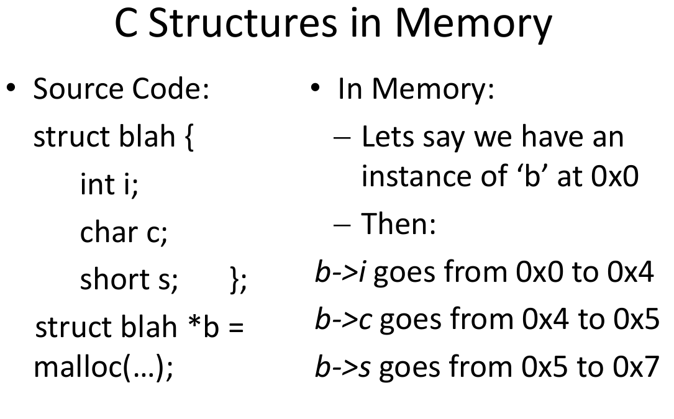

dwarfparse.py (In Volatility)

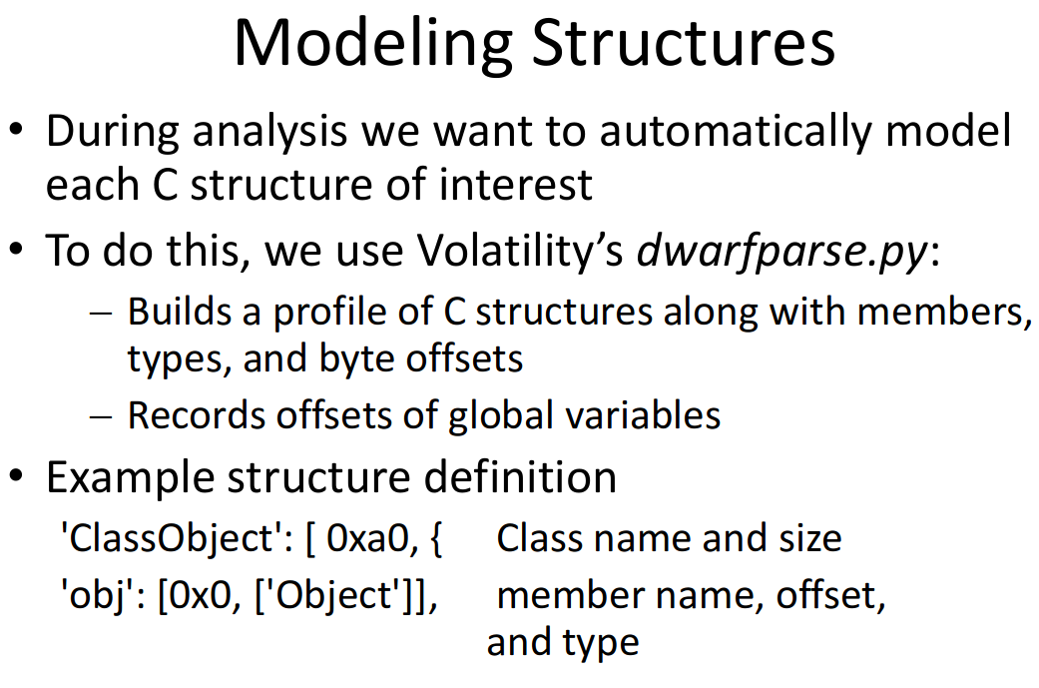

**Volatility**

Popular Memory Analysis Framework

Allows for analysis plugins to be easily written

**RECOVERING PROCESS INFO**

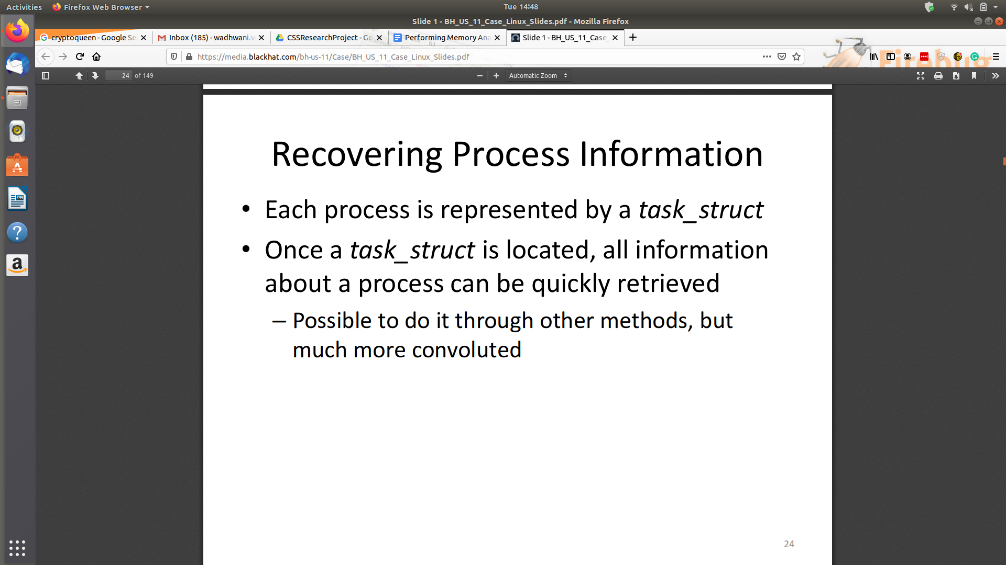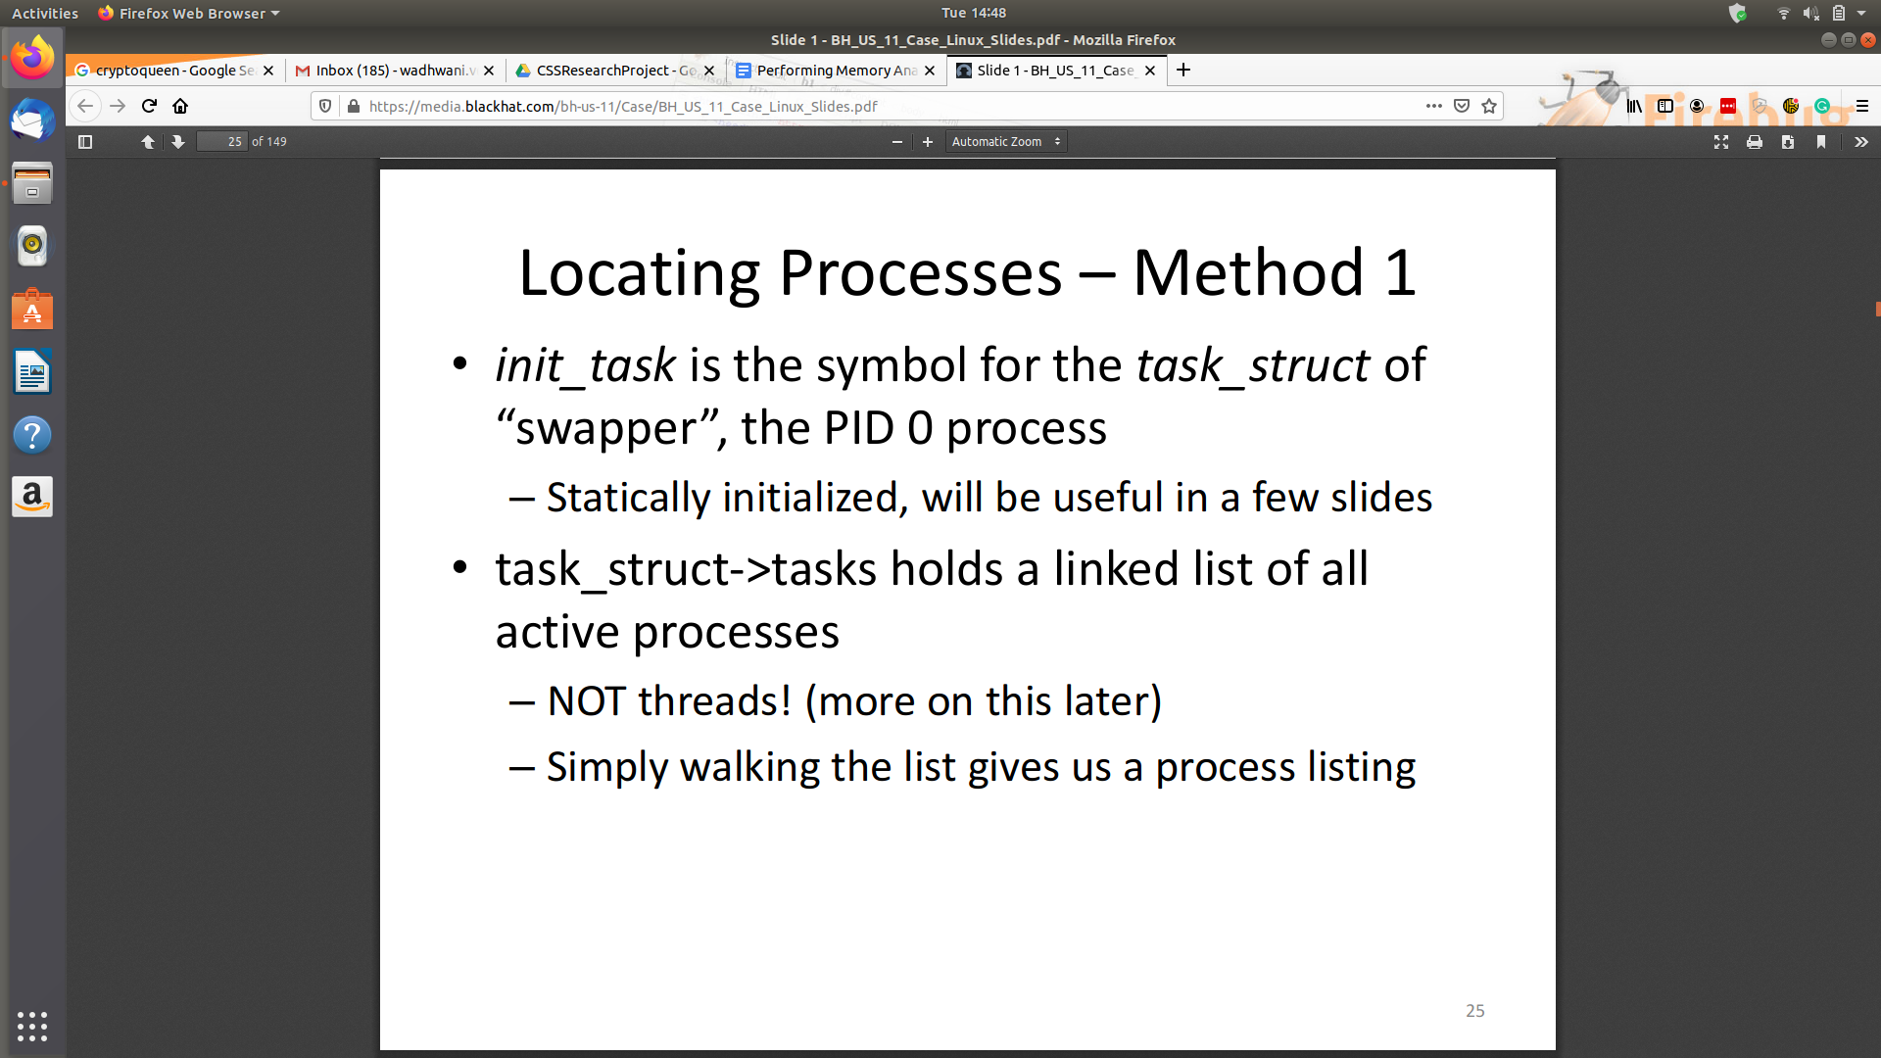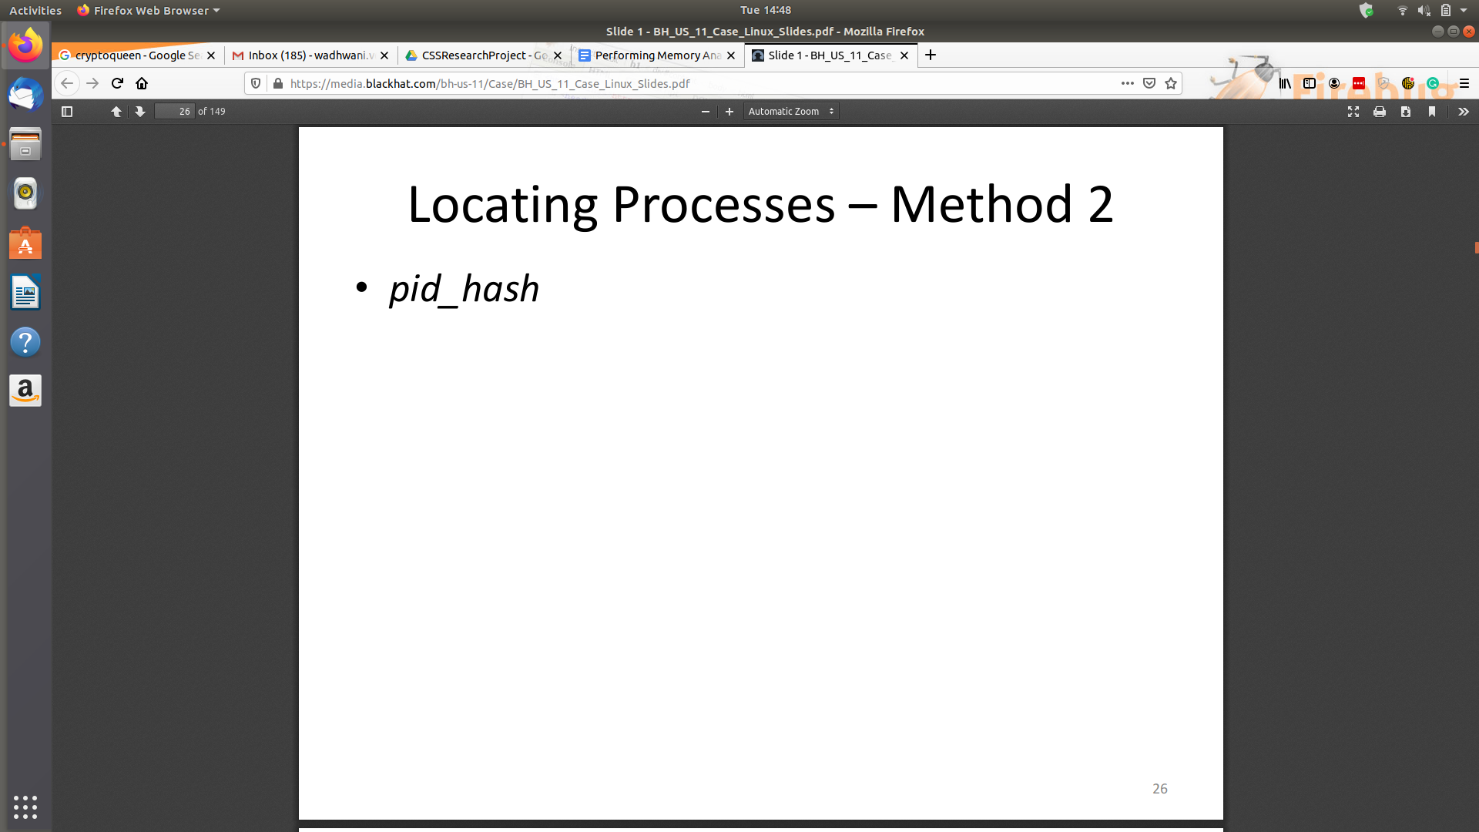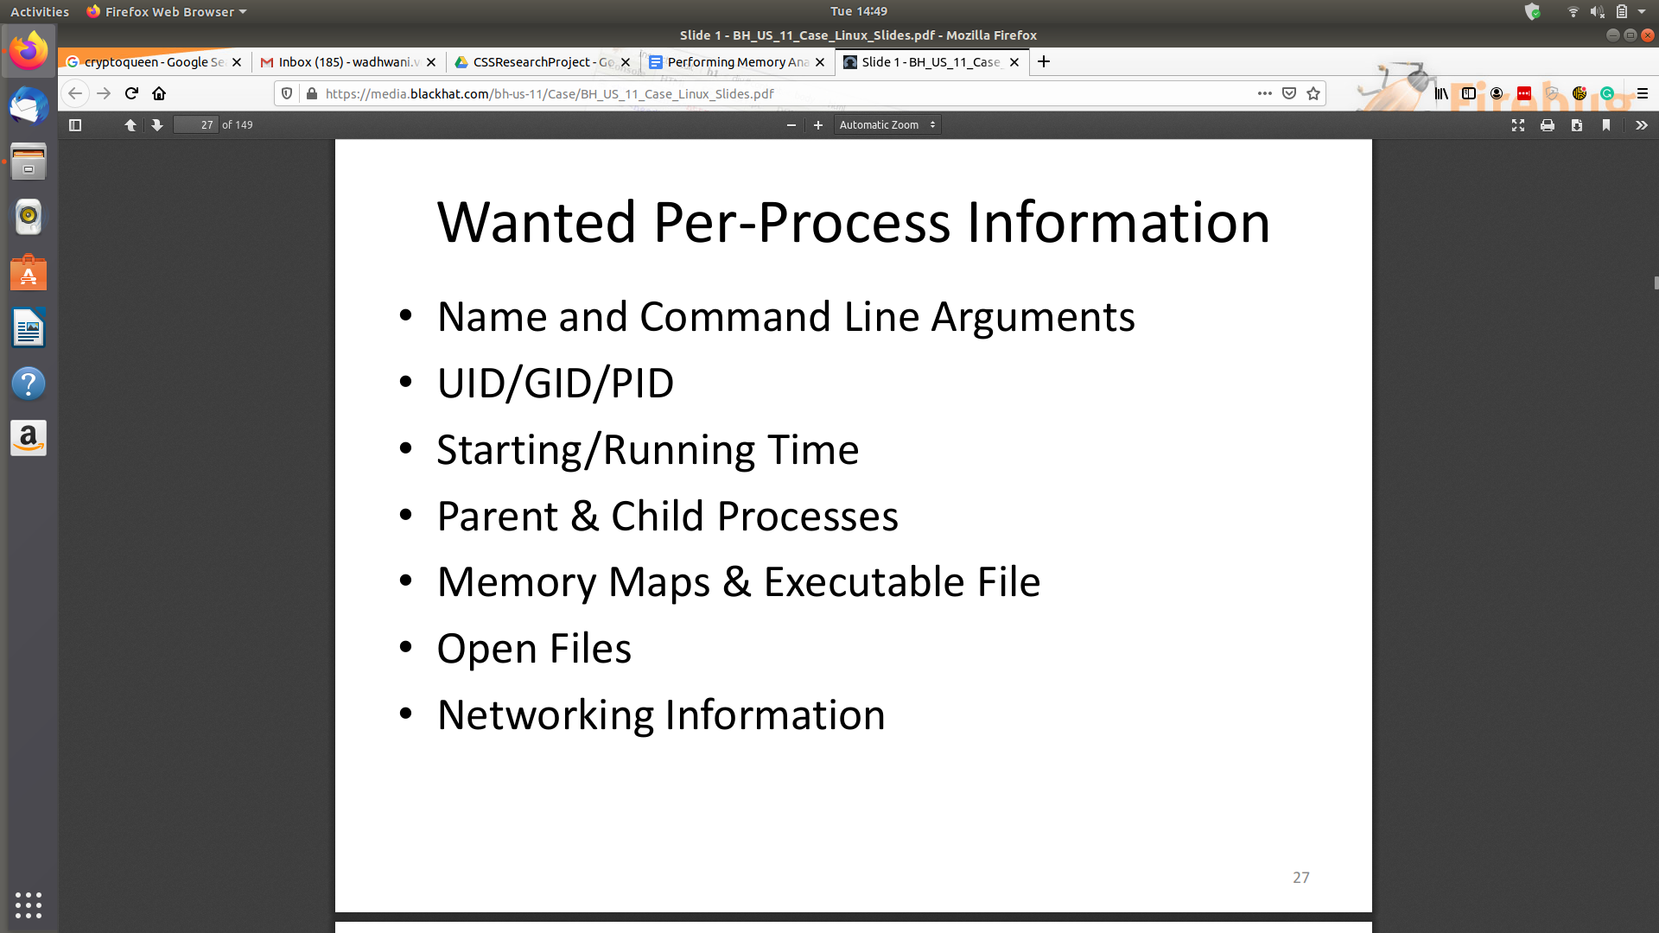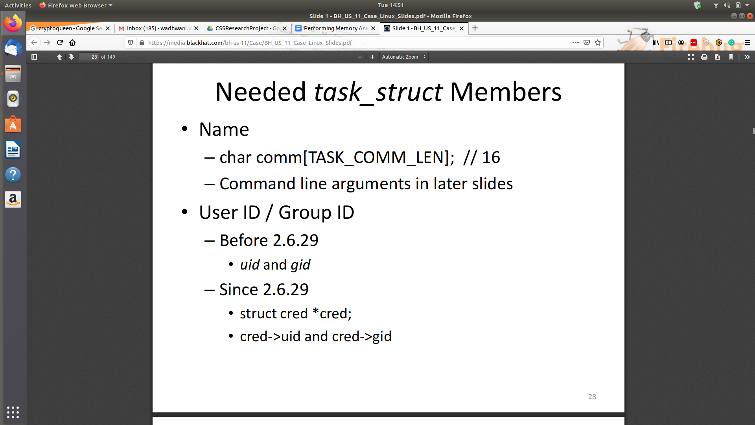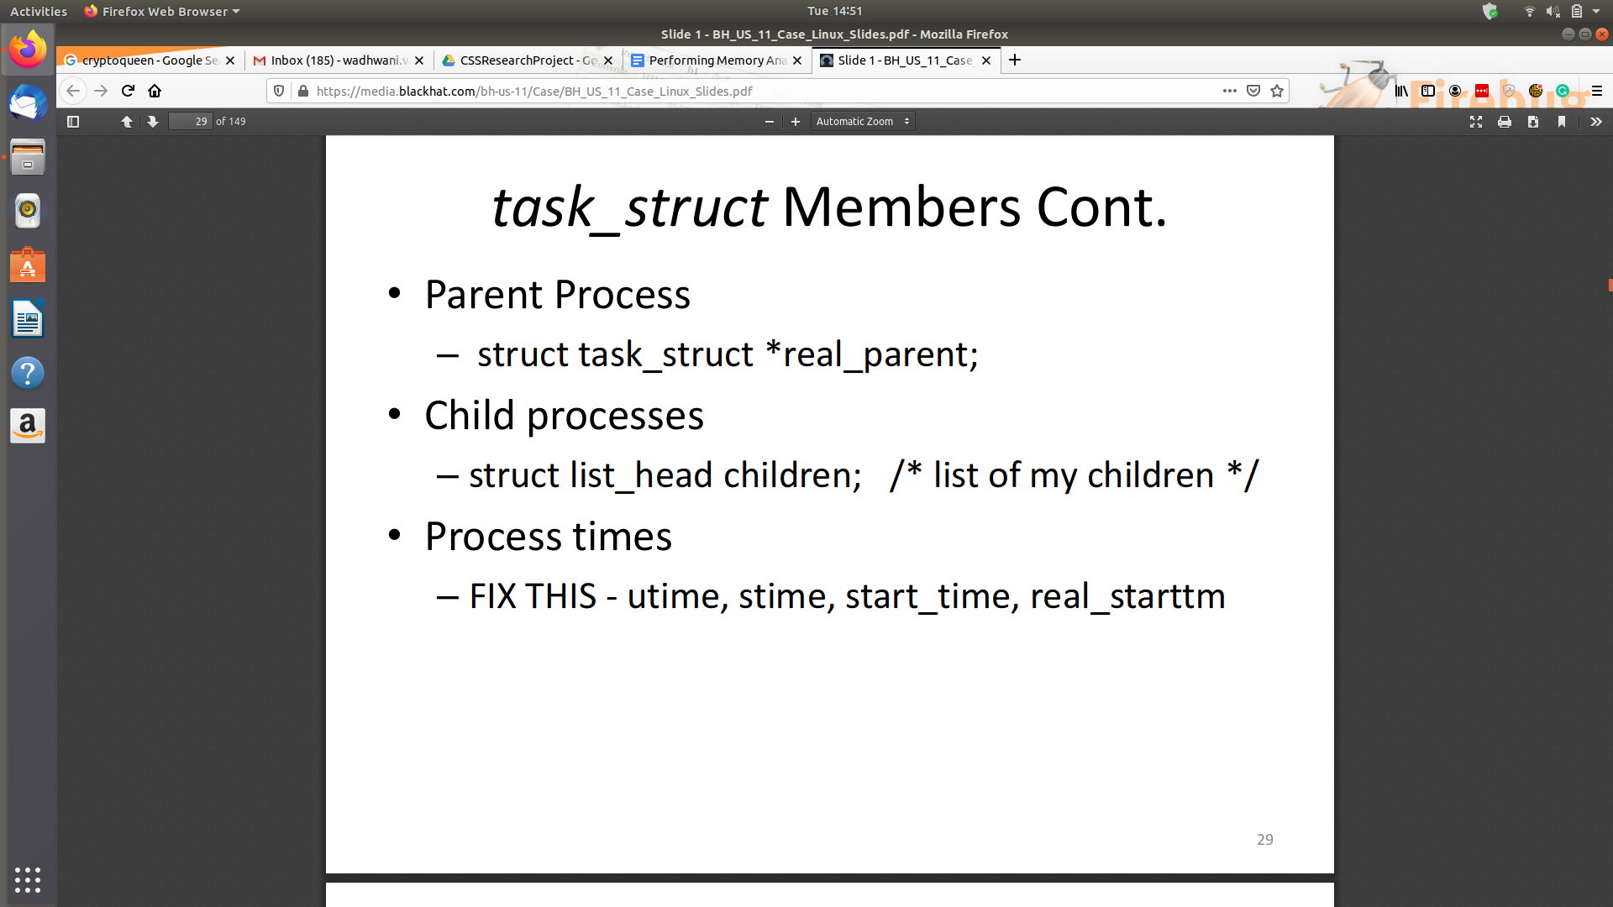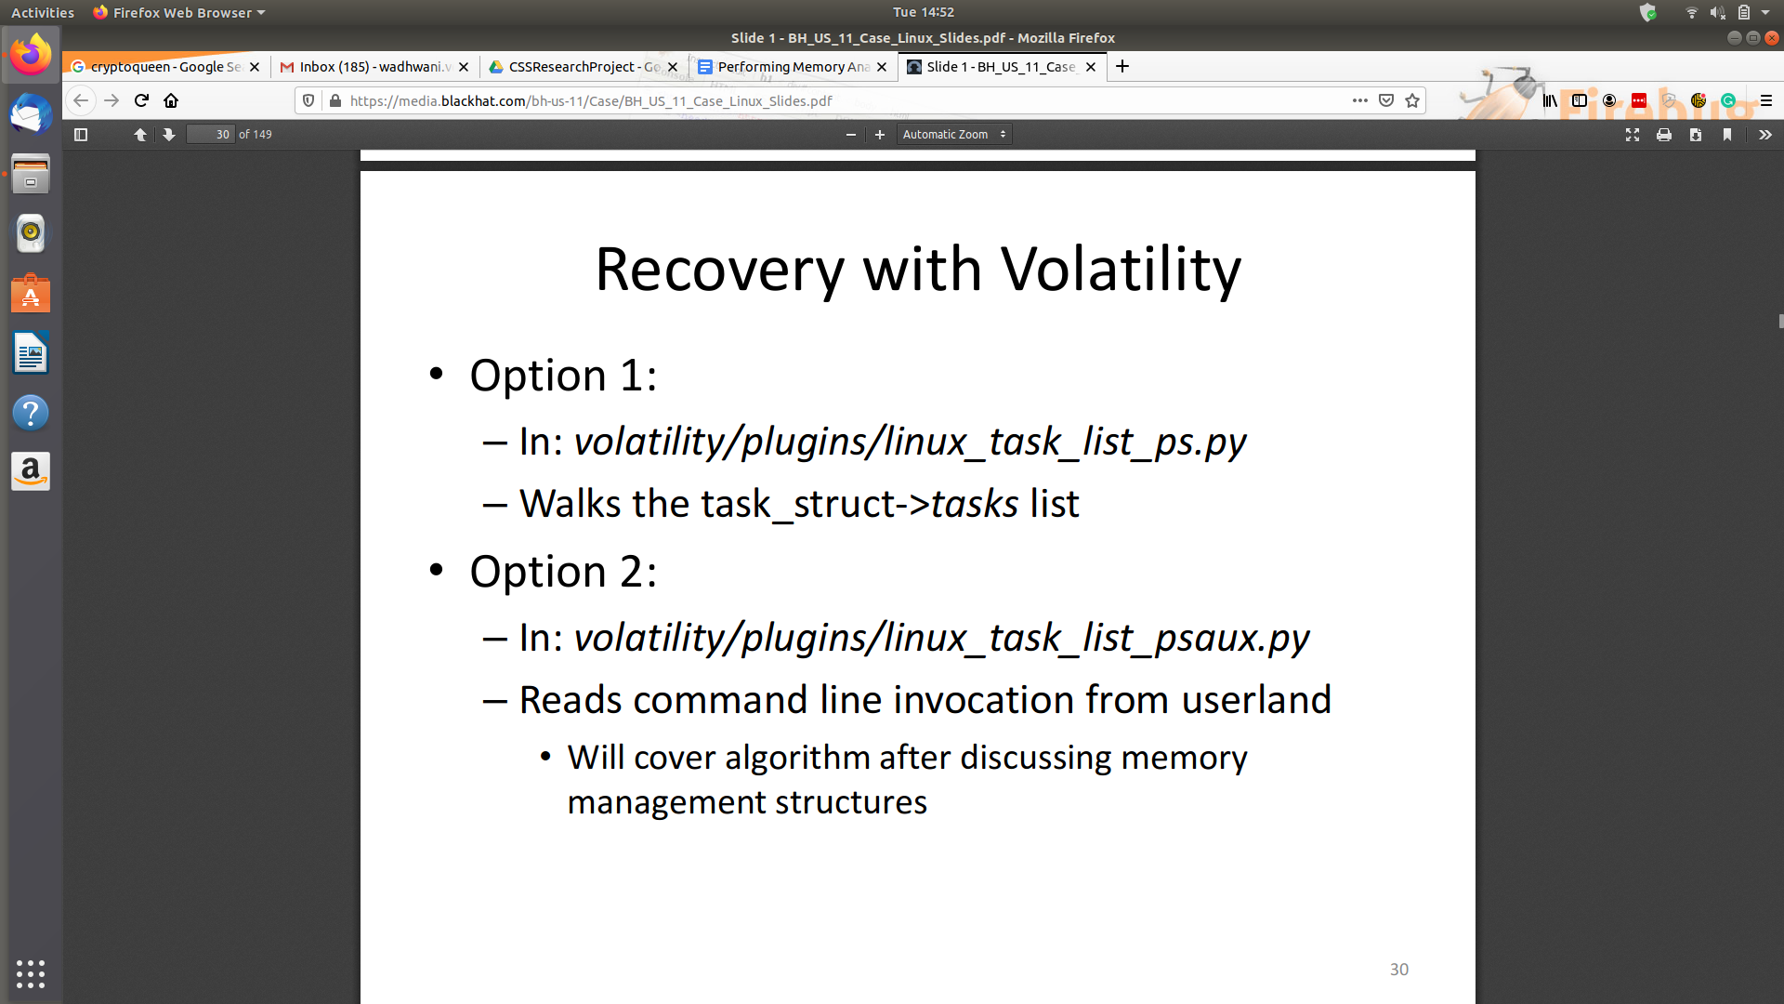

**DEMO**

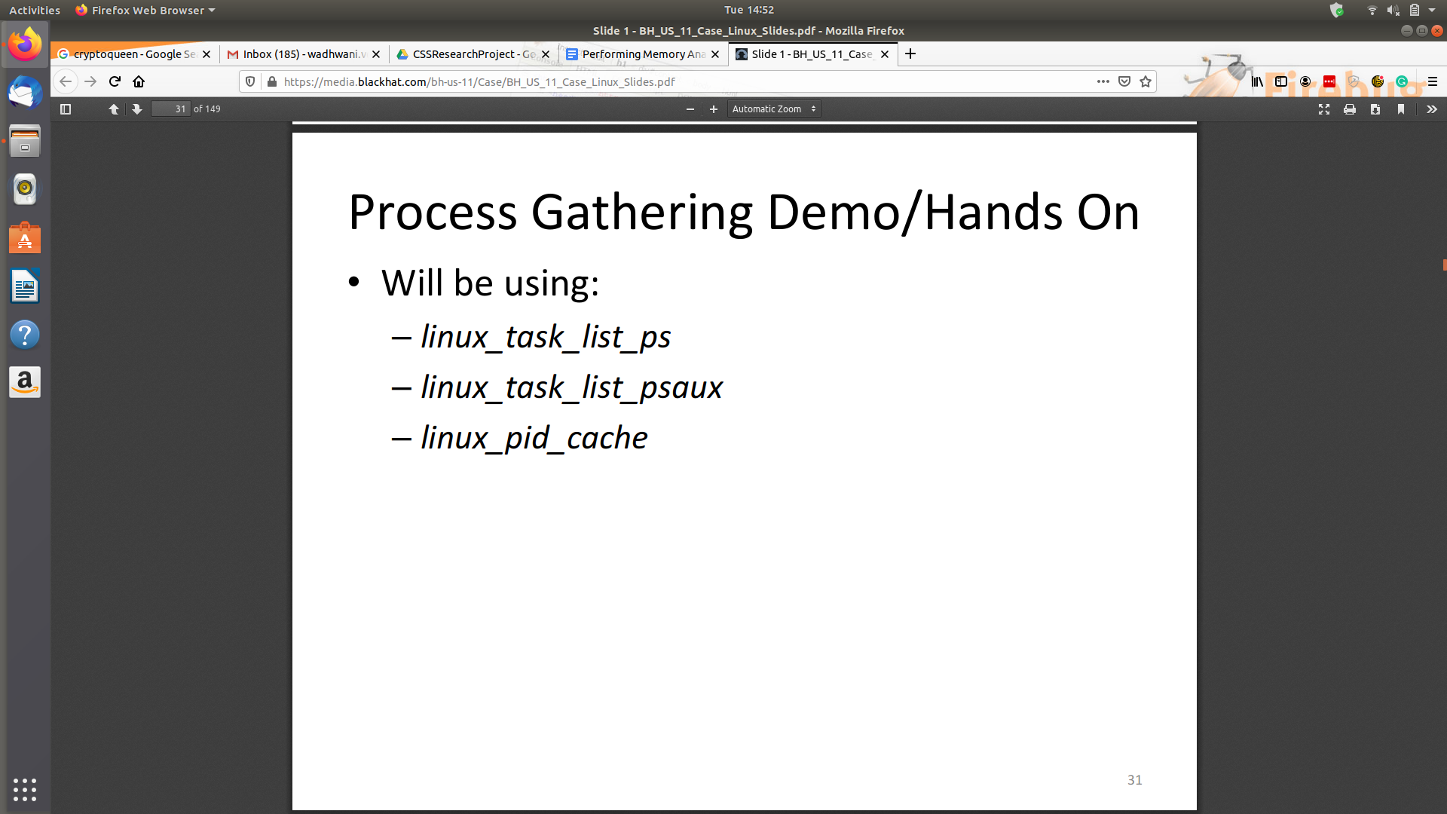

**Slide 31 (To be continued ….)**